Maven in 5 Minutes

1. Download the maven. (version 3.2.1)
2. Configure the maven bin path in system path.

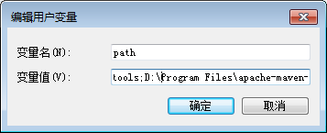

1. Check whether the maven is installed successfully using [mvn –v] in dos

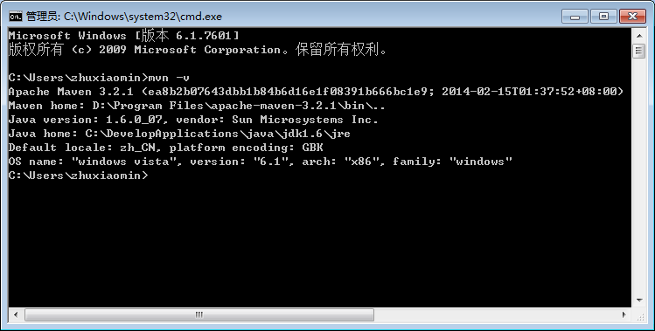

1. Execute below command.

mvn archetype:generate -DgroupId=com.mycompany.app -DartifactId=my-app -DarchetypeArtifactId=maven-archetype-quickstart -DinteractiveMode=false

Below is the generated file structure.

my-app

|-- pom.xml

`-- src

|-- main

| `-- java

| `-- com

| `-- mycompany

| `-- app

| `-- App.java

`-- test

`-- java

`-- com

`-- mycompany

`-- app

`-- AppTest.java